***IASH 2015, the 14TH INTERNATIONAL SYMPOSIUM ON STABILITIY,***

***HANDLING AND USE OF LIQUID FUELS***

***Charleston, South Carolina USA,***

***4-8 October 2015***

**INVESTIGATION OF RELATIONSHIP BETWEEN WATER CONTENT IN BIODIESELS AND MICROBIAL GROWTH AND CONTAMINATION**

Gareth Williams, Leon O’Malley & Graham C. Hill

ECHA Microbiology Ltd., Unit 22&23, Willowbrook Technology Park, Llandogo Road, Cardiff, CF3 0EF, WALES, UK [ghill@echamicrobiology.co.uk](mailto:ghill@echamicrobiology.co.uk)

**ABSTRACT**

Previous research sponsored by the Energy Institute demonstrated a positive correlation between the FAME content of biodiesel and its susceptibility to microbial growth. Those studies were undertaken under conditions where excess water was available to promote microbial growth. Compared to conventional fuels, biofuels containing Fatty Acid Methyl Esters (FAME) have increased propensity to hold water. It is suspected this may promote the ability of microbial growth to occur throughout the bulk fuel phase in storage tanks and impede ability of microbial contamination to be removed by routine tank settling procedures. This paper reports further work sponsored by the Energy Institute to investigate the relationship between water content and microbial growth in biodiesels. Microcosms of biodiesel blends (B0, B10 & B20) with varying total (free and dissolved) water contents (100 ppm, 400 ppm, 1000 ppm & 10000 ppm) were inoculated with low numbers of a consortium of fuel degrading microorganisms and held at 21°C and 70% RH for 14 weeks. The diesel microcosms were agitated weekly. At regular intervals, the microcosms were sampled from four depths (dead bottom (fuel phase), lower third, middle third and upper third) and assessed for water content (IP438) and viable microbial content (IP613). At the end of 14 weeks the fuel filter blocking tendency (IP387) and the total acid number (IP177) were assessed. A visual assessment of the amount of filterable biomass present was also conducted. Additionally, one microcosm was selected for a further study to investigate the influence of settling time on the vertical distribution of microbial contamination and water. Results obtained from the study will assist in developing best practice for handling and storage of biodiesels.

**KEYWORDS**

Microbial growth, microbial contamination, Fatty Acid Methyl Esters, FAME, biodiesel, IP 613, ASTM D7978, IP 438, Water content.

**INTRODUCTION**

It is well documented that the presence of free water in fuels is the most important factor influencing the extent of microbial growth in fuel tanks and systems1. However, less is known about the correlation between levels of water contamination, as measured in representative fuel samples, and levels of microbial growth and contamination. Additionally, there has been little understanding of how the propensity of FAME based biofuels and biofuel blends to hold water influences the ability of microbial contamination to grow and disperse in bulk fuel phase. In conventional fuels, microbial growth is usually restricted to areas of free water accumulation in tank bottoms or surface condensate films where it forms slimes known as biomass or biofilm when adhered to surfaces. Any microbial contamination detected in bulk fuel phase is usually a consequence of physical disturbance of this growth and consequent dispersion of microbial contamination (e.g. by turbulence when a tank is filled). The microbial biomass breaks up to form a freely suspended particulate contamination but with time this contamination will usually settle out. Conversely, FAME based biofuels and biofuel blends may hold water both as dissolved water and as free water dispersed as micro-droplets. This may increase the ability of microbial growth to foul and contaminate bulk fuel in storage tanks and ultimately impact on fuel quality. If free water is held in suspension in fuel, microbial growth may be possible even when water is no longer detected by routine dipping. In addition, it may be more difficult to mitigate contamination by conventional routine housekeeping practices as it will be more difficult to remove water by tank draining and water and microbial contamination may not settle out as readily.

Industry experience suggests that diesel fuels containing FAME can have an increased susceptibility to microbial growth2. The Energy Institute published a review paper in May 20083 which highlighted the need for further research. The Energy Institute has also issued a Technical Bulletin4 which discusses the implications of FAME on microbial growth and provides provisional recommendations for the maintenance of fuel handling facilities.

Subsequent Energy Institute research with microcosms containing various blends of FAME in mineral diesel concluded that at concentrations of 2% FAME and above the susceptibility of fuel to microbial growth, most notably for fungal growth, was significantly increased5. However, the initial research did not investigate the influence of varying the water content. This paper summarises the findings of further laboratory study which will be published as Energy Institute Research Report. The study investigates the influence of water content on the extent of microbiological contamination in hydrocarbon diesel (B0) and two biodiesel fuel blends (B10 and B20). The investigation consisted of two parts. The principal part of the study investigated the relationship between microbiological contamination and water content (100, 400, 1000 and 10 000 ppm total water) in laboratory microcosms of the three fuel blends which simulated fuel in stored in tanks. The microcosms were held under defined conditions of temperature and humidity over a fourteen week test period. For the second part, the settling time for water and microorganisms in microcosms containing B10 and B20 at 400 ppm total water content was investigated. For both parts of the investigation, the vertical profile of microbiological contamination and water content was determined by analysing sub-samples drawn from four distinct depths of fuel in each microcosm. The study aims to establish a better understanding of the relationship between microbiological contamination in biodiesel blends and water content and in particular;

• The influence of FAME concentration on the vertical distribution and concentration of water in fuel;

• The influence of FAME concentration on the vertical distribution and extent of microbial contamination in fuel;

• The influence of total water content on the vertical distribution and extent of microbial contamination in fuel;

• The influence on settling time on the vertical distribution of microbiological contamination and water content in fuel.

.

It is intended that results obtained from the investigation will assist in developing best practice for handling and storage of biodiesel blends. Fuel suppliers have an obligation to implement effective control measures at fuel terminals, which ensure the quality and fitness for purpose of fuel. The industry will be able to better understand how measured values of water content in fuel could influence microbial growth and contamination in the downstream infrastructure. In addition, the settling study will provide information on settling parameters for microbiological contamination in biodiesel, which will form a basis for estimating the effectiveness of routine product settling practices.

**METHODS**

**Part 1 Effect of FAME and Water Content on Microbial Growth in Biodiesel Blends**

The main part of the study investigated the relationship between microbiological contamination and water content (in both inoculated and uninoculated microcosms) in 2 litre microcosms containing biodiesel blends (B0, B10 and B20) held under defined conditions of temperature (21°C) and humidity (70% RH) in an environmental chamber. The microcosms simulated on a small laboratory scale, diesel stored in tanks. Each microcosm was allowed to equilibrate and then water content was measured by Coulometric Karl Fisher titration method (IP 438). For each biodiesel blend, the TOTAL water content was then adjusted to desired levels of 100 ppm, 400 ppm, 1000 ppm and 10,000 ppm. Depending on water holding capacity of fuel this equilibrated to be present as free and/or dissolved water. The water added included low numbers (c. 800 CFU) of a mixed suspension of known fuel degrading bacteria (11), yeasts (9) and moulds (9) derived from stock collections and a variety of field samples. Un-inoculated microcosms also set up as a control.

The vertical distribution of microbiological contamination and water content was determined by analysis of sub-samples drawn from four distinct depths (representing upper, middle, lower and bottom layers) in each microcosm at 1, 2, 4 and 14 weeks.

**Part 2 Effect of Settling Time on Vertical Distribution of Water and Microbial Contamination in Biodiesel Blends**

For Part 2, conducted at the end of the 14 week period, B10 and B20 microcosms set up to contain 400 ppm total water were chosen for a shorter study to investigate the influence of settling time on the vertical distribution of microbial contamination and water within the fuel layers. In this second part, microbial contamination present in the bottom layer was disturbed into the bulk fuel by vigorous shaking and the settling of microorganisms and water was determined in samples drawn from upper, middle, lower and bottom levels after 1 h, 2 h, 6 h, 12 h, 24 h and 48 h.

**Sampling from Microcosms**

The sampling procedure was standardized to minimize the disturbance of fuel layers as far as possible. Sub-samples of 10.25 ml of fuel were removed from each of the four depths to be sampled (upper, middle, lower and dead bottom as shown in Figure 1), starting with the highest sampling height and ending with the lowest sampling height and transferred into dry, sterile, glass universal bottles. The dead bottom sampling position was the lowest position just above any settled free aqueous phase in each microcosm.

After each sampling occasion microcosms were agitated to simulate occasional disturbance of tank contents (e.g. due to product receipts).

*Figure 1 Microcosm with Upper, Middle, Lower and Dead Bottom sampling positions.*

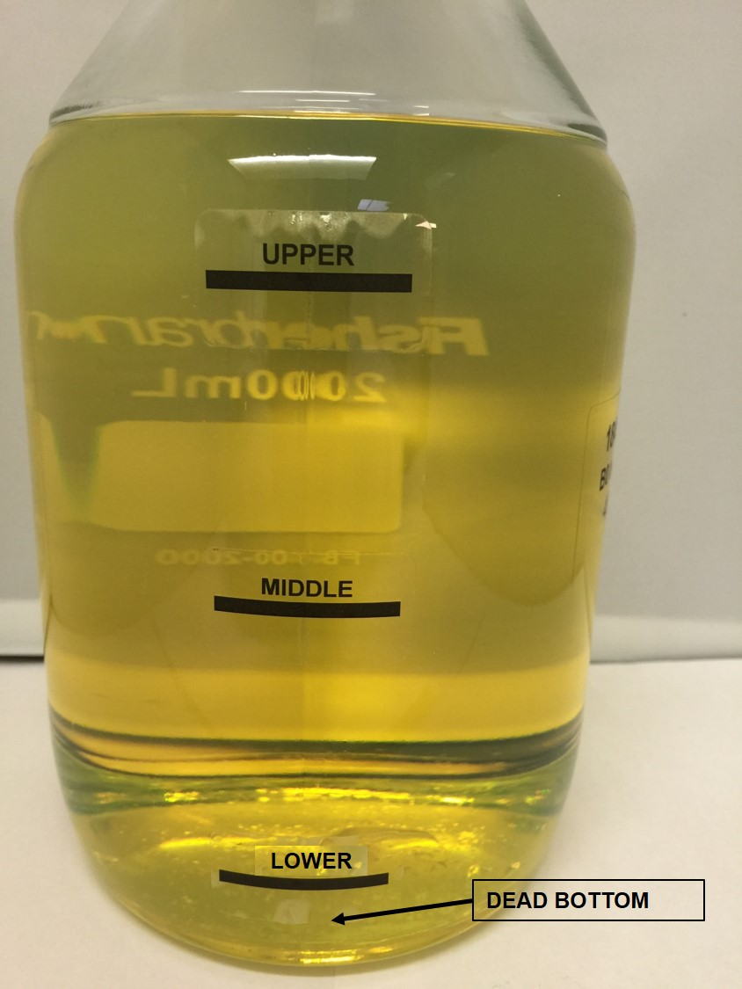

**Test Methods**

Visual Assessment

A visual assessment was made of each microcosm at each assay time to note aqueous phase clarity, fuel phase clarity, fuel / water interface sharpness & cleanliness and the presence of any particulates (specifically particulate typical of microbial biomass).

Where appropriate, selected samples of observed precipitates and deposits were examined by phase contract light microscopy at up to x 1000 magnification to establish whether they consisted of microbial biomass.

Total Viable Count (TVC) in Fuel Phase by IP 613/14

The Total Viable Count (TVC; combined count of bacteria, yeasts and moulds) in the fuel phase of each microcosm was assessed by IP 613 test method.

Water Content in Fuel Phase by IP438/01 Method

The water content of fuel was assessed by coulometric Karl Fisher titration method (IP 438/01). As per method, sodium dioctylsulfosuccinate solution was added and vigorously mixed in sub-samples prior to test to ensure even dispersion and assessment of both free and dissolved water.

Additional Assessments at End of 14 Week Part 1 Study

To assess the diversity of different microbial types a Total Viable Count (TVC) of viable bacteria, yeasts and moulds in aqueous phase (where present) was conducted for inoculated microcosms containing 1000 and 10000 ppm Total Water (for all concentrations of FAME) by serial dilution and standard plate count.

In order to determine the proportion of dissolved water vs suspended free in fuel phase, at the final assessment time point (day 97) of Part 1 of the study, fuel from all microcosms was tested for water content by IP 438/01 before and after centrifugation at 8000 rcf for 10 minutes at room temperature to sediment free water (based on a modification of ASTM D2709-96).

An assessment of the amount of particulate and/or microbial biomass present in each microcosm at the end of the study was conducted by filtering the bottom 800 ml (including fuel, suspended and interfacial particulate and microbial biomass and aqueous phase present) through 0.8 µm mixed cellulose ester membrane filters (based on a modified IP415/07 methodology). The amount of material was assessed by visual examination of material collected on the filters.

An assessment of the impact of any particulate (including any derived from microbial biomass) suspended in bulk fuel phase on the filterability of bulk fuel was determined at the end of the study by IP 387/14 test method (Procedure A).

An assessment of Total Acid Number in bulk fuel phase at the end of the study was determined by IP 139/98 test method.

**RESULTS**

For the B0 microcosms, only very limited amounts of microbial biomass were observed by the end of the study. A discrete visible free water phase was observed at the bottom of all B0 microcosm throughout the study. Conversely, in the B10, and in particular the B20 microcosms, large clumps of brown floccose material similar in appearance to mould was observed in all the microcosms which had a distinct visible free water phase; this was generally the microcosms containing 400 ppm and above total water. In B10 and B20 microcosms containing 400 ppm total water and above, a discrete free water phase was observed throughout the study except for the B20 microcosm with 400 ppm total water microcosm where the free water was no longer visible after 14 weeks. In the B10 and B20 microcosms with 100 ppm total water, no discrete free water was visible by week 2 of the study, although a cohesive lump of brown coloured biomass was observed at the bottom of the inoculated microcosms. Whilst generally more biomass appeared to be present in B10 and B20 microcosms compared to B0, the amount of biomass was reduced where no visible free water was present. Visual assessment indicated that microcosms containing FAME had a tendency to absorb free water. This suggests FAME has two conflicting influences on microbial growth. Increasing FAME concentration increases the amount of microbial growth but only when a discrete free water phase remains present; the capacity of increasing FAME to cause increasing absorption of free water may conversely restrict the extent of biomass production if all free water is absorbed.

These observations were consistent with observations of filters used to collect particulate from the bottom 800 ml of each microcosm at the end of the study (see Figure 2).

*Figure 2 Particulate collected by filtration of B0, B10 and B20 microcosms with 100 ppm, 400 ppm, 1000ppm and 10,000 ppm total water.*

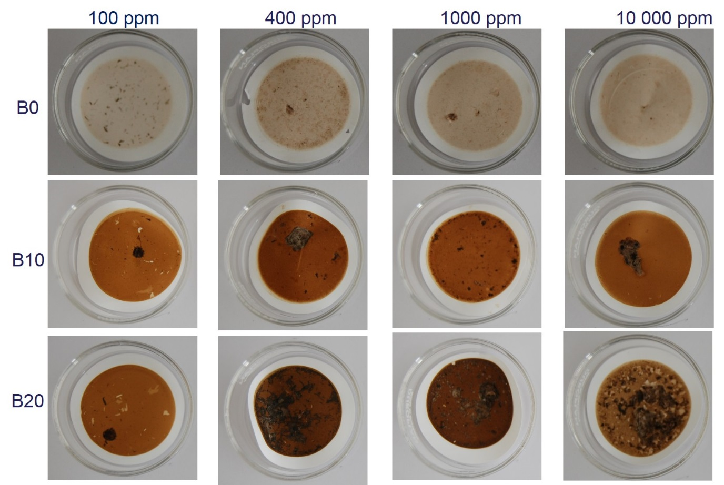

Figure 3a), b) and c) shows the Log10 values of total viable counts in fuel phase (IP 613) at each sampling level versus time for inoculated B0, B10 and B20 microcosms respectively, for each total water content. Microbial counts at all levels in the B0 microcosms were very low or below the limit of detection during the first four weeks of the study. However, by week 14 high microbial counts were detected at the dead bottom sampling position in the inoculated B0 microcosms with 400, 1000 and 10000 ppm total water but lower counts were detected in the bulk fuel layers. For microcosms containing FAME (B10 and B20), very little contamination of bulk fuel phase was indicated (lower, middle and upper layers). No viable counts were detected in B10 and B20 microcosms containing 100 ppm total water during the course of the study, although small clumps of fungal biomass was observed; in probability the cohesive nature of this growth meant that colony forming units were not dispersed and therefore not recovered in samples for the IP 613 test . In inoculated B10 and B20 microcosms containing 400 ppm total water and above, some microbial contamination was detected in the dead bottom samples by week 2 and this increased to high levels over the course of the study.

Assessment of total viable counts for bacteria, yeasts and moulds in aqueous phase for inoculated microcosms containing 1000 and 10000 ppm total water revealed a shift from bacterial to fungal growth with increasing FAME concentration (Figure 4). High numbers of bacteria were detected in the aqueous phase of the B0 and B10 microcosms at the end of the study, whereas virtually no bacteria were detected in the B20 microcosms. When compared to the B0 microcosms, higher numbers of viable yeasts and moulds were detected in the B10 and B20 microcosms at the end of the study. The shift from bacterial to fungal growth with increasing FAME concentration confirms results of the previous Energy Institute study into microbial susceptibility of biodiesel blends. This is believed to be due to the fact that FAME will decrease the water activity (aw) in aqueous phase associated with fuel and therefore favour growth by yeasts, and in particular moulds, which are more tolerant of conditions with a lower water activity. The previous Energy Institute study also highlighted the influence of acid production due to fungal activity in lowering pH which will not favour many bacterial species.

As expected, the water content recorded in fuel phase increased with increasing FAME concentration in the fuel blend tested. Water content results obtained at Week 14 are shown in Figure 5. For the B0 microcosms, the measured water content in bulk fuel was similar in all microcosms regardless of the nominal total water content. In contrast, for both B10 and B20 microcosms a noticeable increase in measured water content in fuel was observed in microcosms containing a nominal total water content of 400 ppm compared to those containing 100 ppm. However, there was little if any further increase in measured water content in bulk fuel with further increase in total water content to 1000 ppm or 10000 ppm.

Generally, there was little difference in water content measured at the upper, middle and lower layers for all fuel blends. Measured water content in the dead bottom layer was generally higher than in the layers above although the results obtained for this sampling position tended to be more erratic. This is likely to be due to the proximity of the sampling location to settled free water in the microcosms; the fuel would in probability have a heterogeneous dispersion of suspended free water droplets making consistent sub-sampling for water analysis difficult. Apart from the dead bottom sampling position, water content measurements for bulk layer samples still remained within current normal specifications for diesel (200 ppm) throughout the course of the study in all fuel microcosms regardless of overall water content and FAME content.

*Figure 3a). Total Viable Count (TVC) in Fuel Phase by IP 613 at each sampling level (upper, middle, bottom and dead bottom) for B0 microcosms during course of the study.*

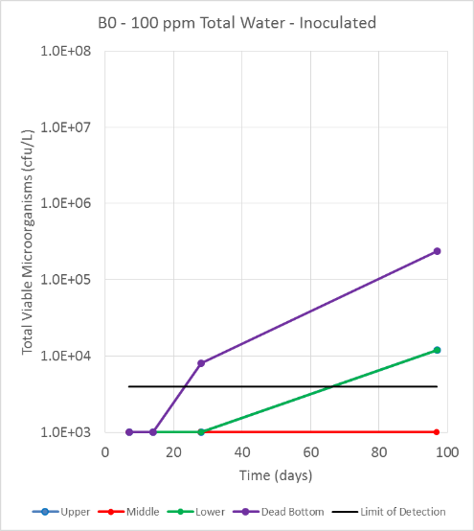 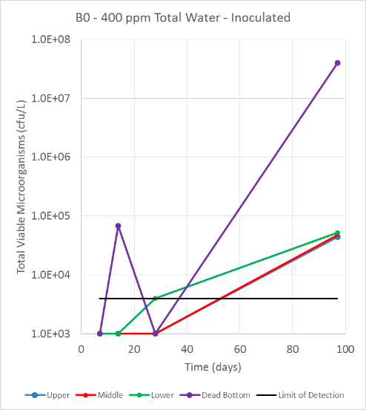

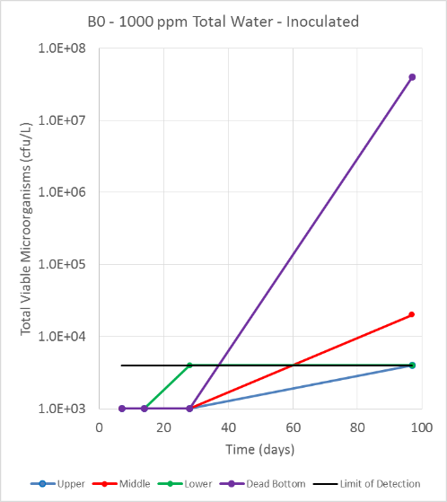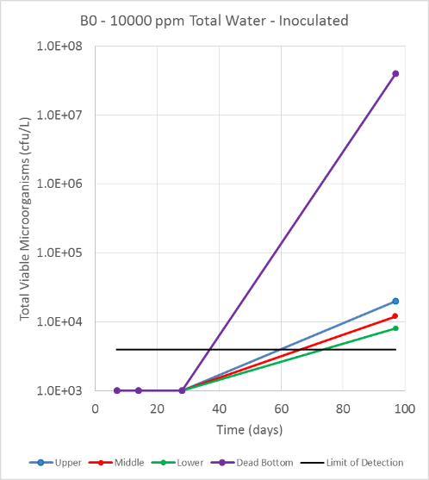

*Figure 3b). Total Viable Count (TVC) in Fuel Phase by IP 613 at each sampling level (upper, middle, bottom and dead bottom) for B10 microcosms during course of the study.*

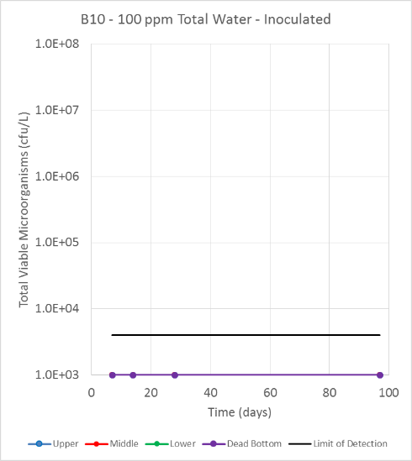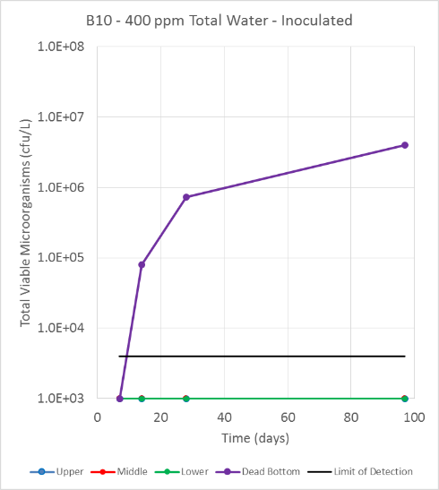

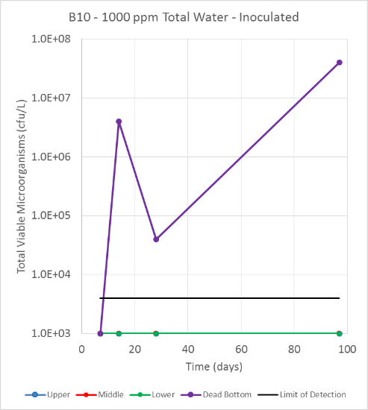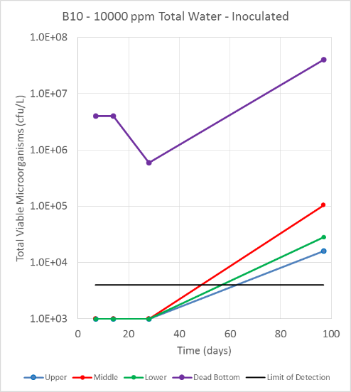

*Figure 3c). Total Viable Count (TVC) in Fuel Phase by IP 613 at each sampling level (upper, middle, bottom and dead bottom) for B20 microcosms during course of the study.*

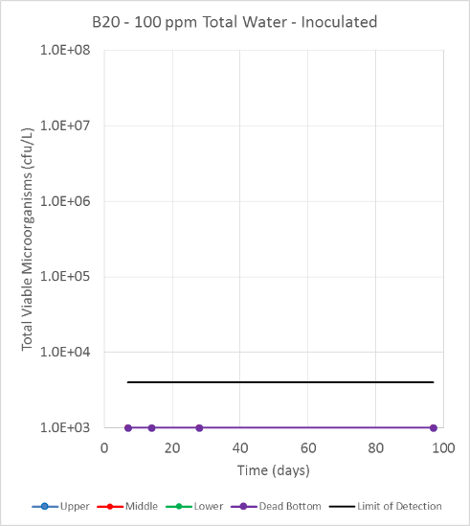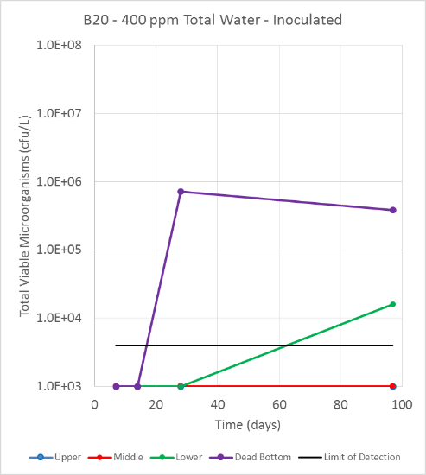

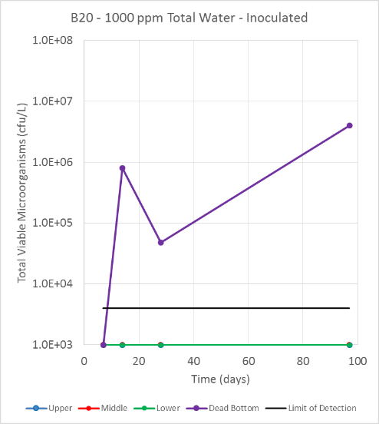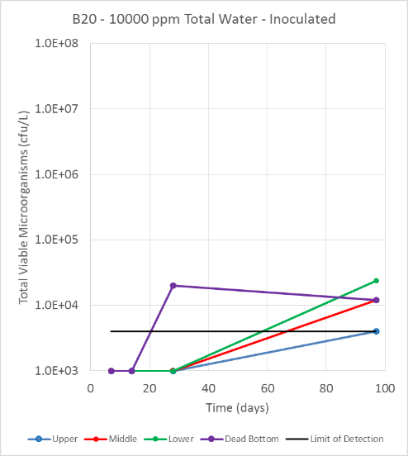

*Figure 4. Total Viable Count (TVC) of Bacteria, Yeasts and Moulds in Aqueous Phase of Microcosms containing 1000 and 10000 ppm total water.*

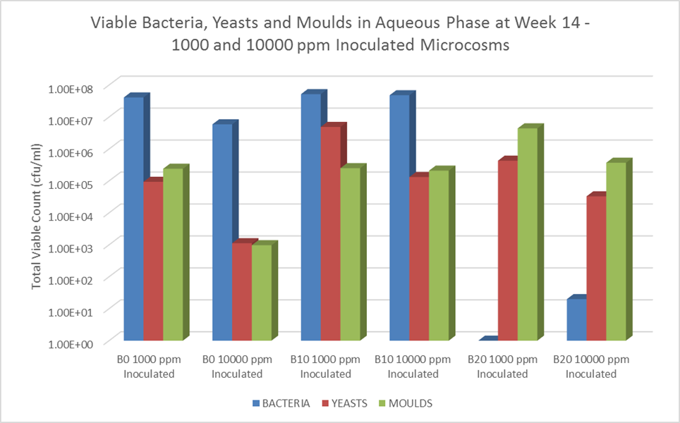

*Figure 5. Water Contents determined at each fuel level in all microcosms at the end of the 14 week study****.***

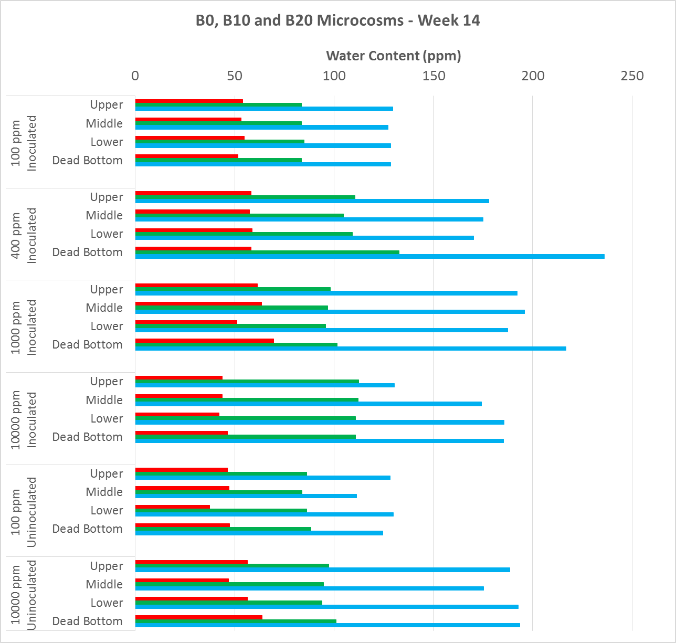

Whilst the total water content recorded at each level in fuel phase was observed to increase with increasing FAME concentration, the corresponding free water content determined at each level was observed to not increase appreciably. The average free water content of fuel in the bulk fuel layers (upper, middle and lower) was 14, 12 and 15 ppm for B0, B10 and B20 blends respectively, compared to average total water contents of 52, 97 and 161 ppm in bulk fuel layers for B0, B10 and B20 blends respectively. The majority of water at these fuel layers would thus appear to be contributed by either dissolved water or suspended water micro-droplets too fine to be centrifuged out.

The Total Acid Number (TAN) in bulk fuel was seen to increase with increasing FAME concentration. However, no discernible trend between total acid number and total water content or microbial content was observed for any of the fuel blends tested. This is perhaps not surprising given little penetration of microbial contamination in bulk fuel layers was seen.

Filter blocking tendency (FBT) of bulk fuel from microcosms was seen to be higher for B20 compared to B0 and B10 blends. There was no discernible difference between B0 and B10 and there was no discernible correlation between FBT and water content for any blend. The higher FBT for B20 is suspected to be related to particulate other than microbial growth, given there was little evidence of microbial contamination in the bulk fuel layers of the B10 and B20 microcosms. However, the apparent absence of any impact on FBT of bulk fuel (middle layer), as measured by IP 387 in this study, should be treated with caution as the assessment of particulate by filtration of the bottom fuel layers through a 0.8 µ membrane filter by modified IP 415 (see Figure 2) gave clear evidence that if bottom contamination is disturbed into fuel it will influence filterability. The bottom of B10 and B20 microcosms containing 400 ppm total water and above took considerably longer to filter than B0 microcosms and microcosms with only 100 ppm total water; in some cases multiple filters were needed to filter the 800 ml test volume. The extent to which microbial contamination will influence filterability will depend on settling times. This was investigated in the second part of the study for B10 and B20 microcosms containing 400 ppm total water.

Figure 6 shows TVC of viable microrganisms at each fuel level of the B10 and B20 microcosms containing 400 ppm nominal total water, determined 1 h, 2 h, 6 h, 12 h, 24 h and 48 h after vigorous shaking. From this data settling rates of microorganisms from bulk fuel layers can be extrapolated in terms of time taken for a given % of microbial contaminants to settle. For B10, the number of viable microorganisms detected in all bulk fuel layers was observed to decrease by 80% at between 1 to 2 h (equating to a settling rate of 8.5 to 17 cm/h), by 90% between 2 to 12 h (a settling rate of 1.4 to 8.5 cm/h) and by 99% after between 24 to 48 h (a settling rate of 0.4 to 0.7 cm/h). Viable microorganisms decreased to below detectable levels (<4000 cfu/L) for the upper and lower fuel layers by 48 h (a settling rate of 0.4 cm/h). In contrast, the settling of microorganisms from bulk fuel layers in B20 was much slower. An 80 or 90% decrease in viable microorganisms from bulk fuel layers of B20 took 24 h (a settling rate of 0.7 cm/h), and a 99% decrease took 48 h (a settling rate of 0.4 cm/h). A decrease in viable microorganisms below detectable levels in the bulk fuel was not achieved in the 48 h settling study test period.

It is expected, as governed by Stoke’s Law, that microbial particulate will settle at a rate dependent on its size; aggregates of microbial cells or clumps of fungal biomass will settle faster than individual microbial cells6. It should be noted the IP 613 test counts each microbial particle as a single CFU regardless of its size or whether it is a clump of cells or a single cell. Photographs of the IP 613 assay bottles are provided in Figure 7 and give a good pictorial representation of the extent of contamination at each level over time.

*Figure 6 Total Viable Microorganisms by IP 613 in upper, middle, lower and bottom fuel layers of B10 and B20 microcosms with nominal 400 ppm total water, over a 48 h period after shaking.*

**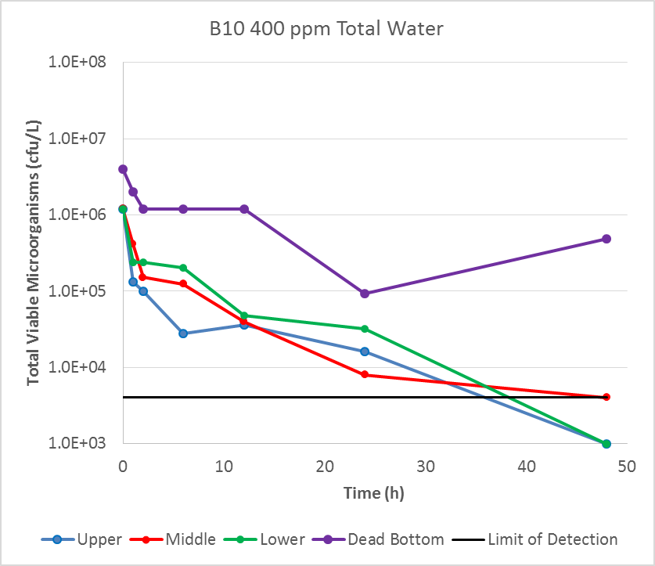****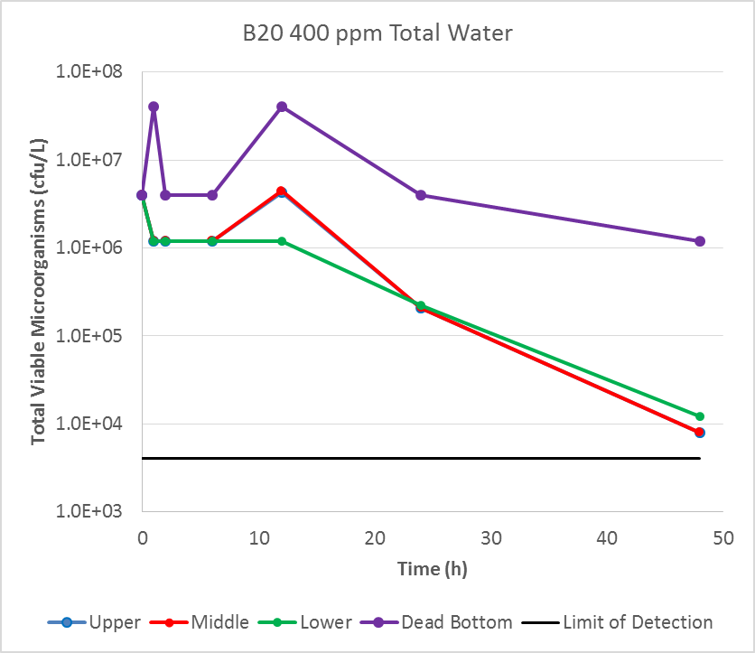**

Settling of water from the bulk fuel layers was quicker in B10 compared to B20. Immediately after disturbance of water from the bottom of the microcosm into bulk fuel, the water content in the upper, middle and lower fuel layers was determined to be 126, 114 and 105 ppm respectively. After settling for 48 h, the water content of the of the upper, middle and lower layers had decreased to 91 ppm, 91 ppm and 96 ppm respectively (representing a percentage decreases of 27%, 21% and 9% for the upper, middle and lower layers respectively). Overall, for B20, the settling of water was slower, as water content in the bulk fuel layers was found to decrease from 154, 170 and 170 ppm respectively for the upper, middle and lower fuel layers to 96, 155 and 159 ppm at 48 h (representing decreases of 38%, 9% and 7 % respectively).

*Figure 7. IP 613 assay bottles for upper, middle, lower and bottom fuel layers of B10 and B20 microcosms with nominal 400 ppm total water, over a 48 h period after shaking.*

*Note; the number of red spots (colonies) indicates the number of microbial CFU/litre. The size of the spots is not related to the original size of the microbial particle which formed the colony*

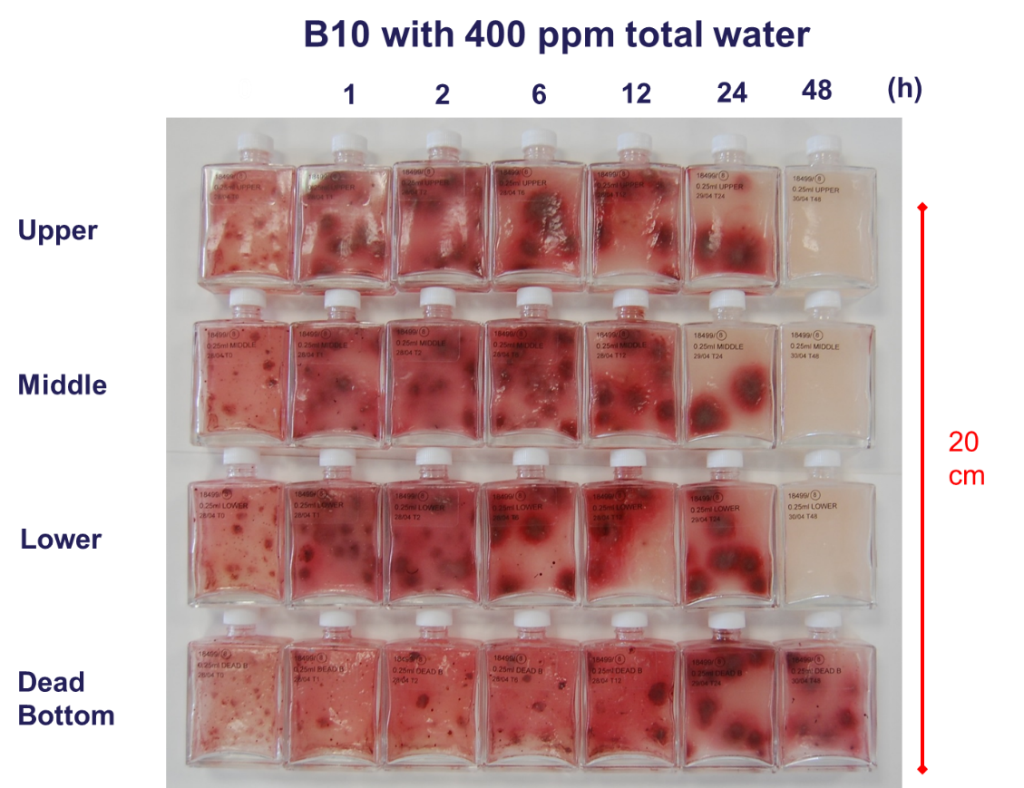

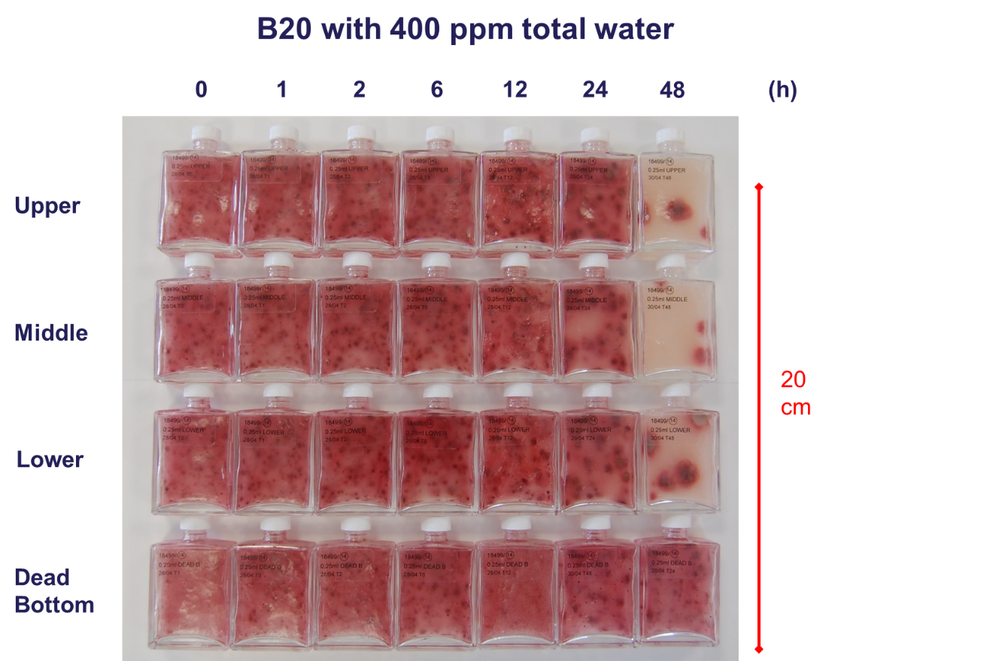

**DISCUSSION**

Based on the findings of the study it is possible to review the likely effectiveness of existing commonly applied fuel housekeeping practices and make recommendations in respect of storage and handling of biodiesel blends. The two critical elements of housekeeping are control of water, for example by regular tank draining, and settling of product after receipts to avoid transfer of water and microbial contamination to tanks downstream with distributed fuel.

**Control of water**

The presence of any water in tank bottoms will provide an opportunity for growth of microorganisms and potential contamination of bulk fuel if this growth is disturbed. Evidence from this study suggests that, in order to limit microbial growth in tank bottoms, a total water content of below 400 ppm should be maintained in fuel storage tank as a whole. It can be calculated that for 10 m height of diesel in a typical storage tank of 35 m diameter, a total water depth of only 4 mm would result in a total water content in the tank of over 400 ppm, the concentration which has been shown to significantly increase the extent of microbial growth. In practice, however, because much of this water will be present as a settled free water phase, measured water content of bulk fuel will be significantly lower. To minimise the opportunity for microbial growth, the study indicates that measured water content in bulk fuel should be less than 150 ppm and ideally nearer 100 ppm.

The imperative for regular draining of water from tanks and control of water ingress is stressed. Even very modest depths of water have the potential to result in significant levels of microbial growth.

**Settling of Product**

A commonly quoted guidance for settling of fuels after recipt into storage tanks is one hour per 30 cm of product depth. However, in practice this is usually only applied in critical situations (e.g. aviation fuels where particulate contamination is suspected) and is rarely applied for diesel fuels due to logistical demands. The study indicates 1 h per 30 cm is likely to be just about adequate to permit settling of a sufficient amount microbial material from bulk fuel for B10. However, it is unlikely to be adequate for settling of microbial material from B20 biofuel blends or higher FAME concentrations. In such cases, required settling times are unlikely to be practical in situations of high turnover. This will necessitate greater emphasis on other measures such as tank draining and testing.

**Testing**

Testing of bottom samples or drain samples from storage tanks on a routine basis for microbiological contamination, particular in cases where significant amount of visible material possibly of microbial origin are observed, will help highlight the potential for fuel quality issues. It is recommend procedure wherever water accumulation results in overall total water concentrations (i.e. in the tank as a whole including settled water) 400 ppm and above. This will typically be indicated where measured water content of bulk fuel exceeds 100 ppm.

**SUMMARY**

A laboratory study was undertaken using microcosms to investigate the relationship between microbial growth and total water contents of 100 ppm, 400 ppm, 1000 ppm and 10,000 ppm in B0, B10 and B20 biofuel blends. The study confirmed previous findings that, overall, microbial growth increased with increasing FAME concentration and was significantly greater in B10 and B20 blends compared to B0. A shift from bacterial growth to fungal growth was noted in FAME containing diesel. As expected, water content in diesel increased with increasing FAME concentration. However, microbial contamination in bulk fuel phase (upper, middle, lower) did not generally correlate with the water content detected at each level. Even though microcosms were agitated weekly, the vast majority of microbial contamination remained in the bottom, even when relatively high water contents were detected in fuel; the water in fuel was found to be predominantly due to dissolved water (or very small suspended micro-droplets) and not free water.

Irrespective of FAME concentration when nominal total water in microcosms was only 100 ppm very little microbial growth was observed. For all fuels, increase in the total water content of microcosms resulted in an increase in the amount of microbial biomass in aqueous phase; this increase in microbial biomass was most noticeable on increasing the total water content from 100 to 400 ppm. This equated to water content measurements of bulk fuel increasing from just over 100 ppm to over 150 ppm.

The study investigated settling rates of microorganisms and water in fuel and demonstrated significantly longer settling times were required for B20 comparted to B10.

The data highlights that only a few mm of water in a typical storage tank can lead to significant microbial growth in B10 and B20 blends. It highlights the need to minimise water ingress and accumulation and, where this is not possible, assess the risks to fuel quality by regular testing for microorganisms and water content.

**Acknowledgements**

This study is to be published as an Energy Institute Research Report which will provide further details.

The authors wish to thank the Energy Institute for funding and the support of the Energy Institute Microbiology Committee and in particular Elaine McFarlane, Neil Whitehead, Ramya Venkataraman.

**REFERENCES**

[1] IP Guidelines for the Investigation of the Microbial Content of Petroleum Fuels and for the Implementation of Avoidance and Remedial Strategies, 2nd Edition, Energy Institute (IP Publications), 2006

[2] E. C. Hill & G. C. Hill, Strategies for resolving problems caused by microbial growth in terminals and retail sites handling biodiesels in *Proceedings of the 11th International Conference on Stability, Handling and Use of Liquid Fuels*, IASH, Prague 2009.

[3] Implications of Biofuels on Microbial Spoilage and Corrosion within the Fuel Distribution Chain and End Use, Literature Review by A. Price, (2008), Energy Institute, London

[4] EI Microbiology technical bulletin sheet 1: Microbial growth in biodiesels and other fuels containing fatty acid methyl esters (FAME). (May 2011)

[5] EI Research Report: Investigation of microbiological susceptibility of biodiesel and biodiesel blends, 2014.

[6] E. C. Hill, Safe, acceptable, anti-microbial strategies for distillate fuels in *Proceedings of the 5th International Conference on Stability and Handling of Liquid Fuels*, IASH, Rotterdam 1994.